LETTER OF INTENT

BETWEEN
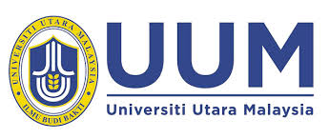
UNIVERSITI UTARA MALAYSIA
06010 UUM, Sintok, Kedah Malaysia

Universiti Utara Malaysia and , hereby agree to prepare in future the Memorandum of Understanding (MoU) to enhance mutual cooperation and exchanges in many academic fields with an aim to encourage the long-term development of both sides, and to hereby reach to following understanding:-

- To work together on the following goals with the :
- Exchange of academic staff;
- Exchange of students;
- Collaboration of joint research projects;
- Coordination of joint educational projects;
- Joint publication of research and educational materials;
- Organization of joint student development (co-curriculum) activities, such as academic conferences, lectures, special short training courses, seminars and symposium.

- For future collaboration, both parties and their respective institutes, centres, and/or academics agreed to adhere and comply with the necessary steps that are required from the official protocol of each parties;

- It is understood that either party may terminate this Letter of Intent at any time by giving written notice to the other.

(d) This LoI serves only as a record of both parties’ intentions and does not constitute or create any legally binding or enforceable obligations, expressed or implied’.

This Letter of Intent shall take effect when duly signed by both parties.
Signed by, for and on behalf of  UNIVERSITI UTARA MALAYSIA (UUM)  Prof. Dato’ Seri Dr. Mohamed Mustafa  Ishak  Vice-Chancellor  Universiti Utara Malaysia  Date: | Signed by, for and on behalf of  Date:

